Use one table-Create/Update/Insert .Perform joins inside the View

CREATE VIEW:

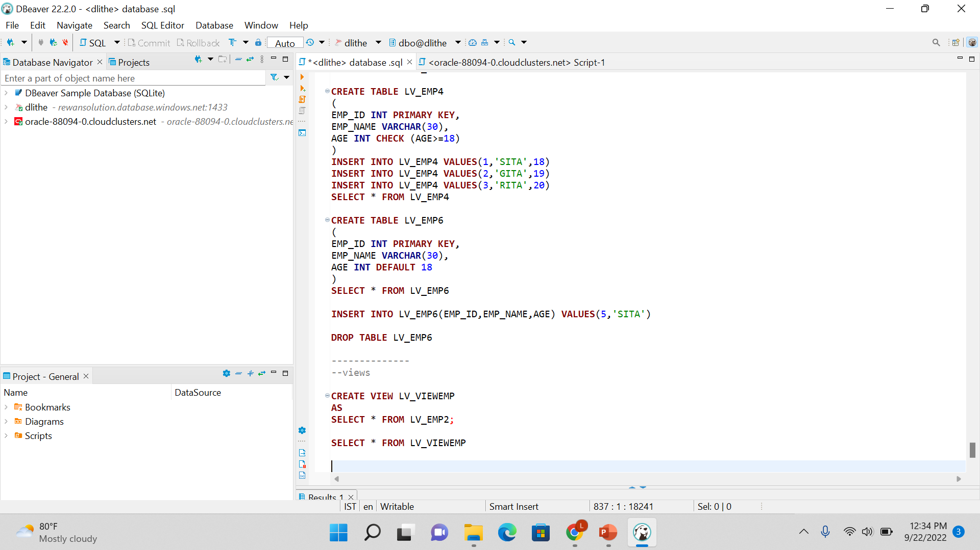

VIEWS ON JOINNS:



